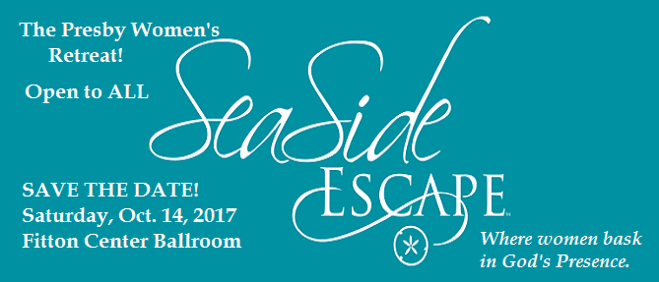
REGISTRATION
Saturday, Oct. 14 – 8:30 a.m. – 4 p.m.
$40 (Includes meals and all retreat materials)
(Scholarships available upon request)

NAME: ________________________________________________________________________

ADDRESS: ________________________________________________________
_________________________________________________________
EMAIL: _________________________________________________________________

CELL PHONE: ______________________________

FOOD ALLERGIES: ______________________________________________________

Checks Payable to: The Presbyterian Church
Mail Registration to: Rosie Jennings, Director of Family Ministries
The Presbyterian Church, 23 South Front Street, Hamilton, OH 45011

